1 - Find the IP of the camera

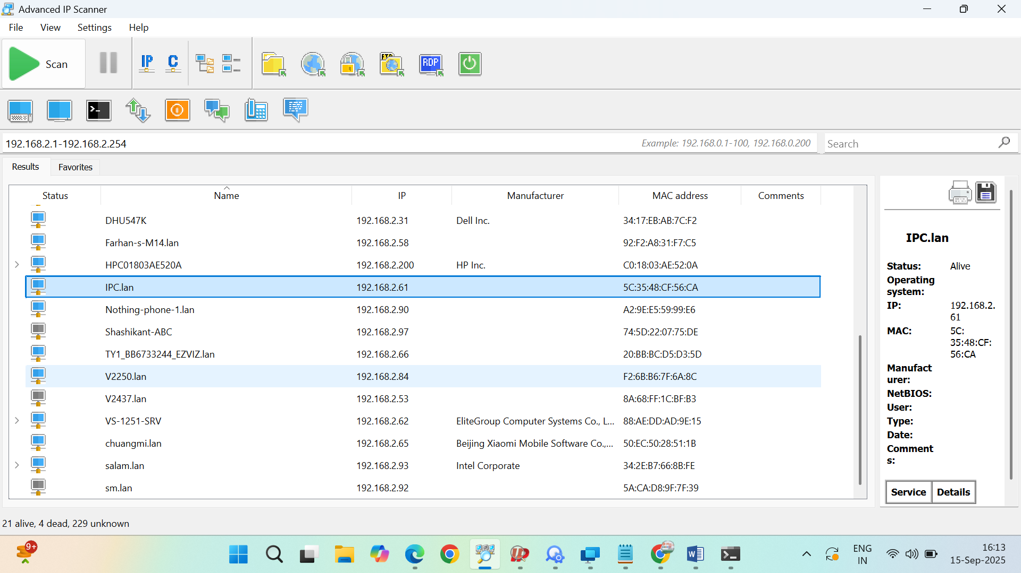

2 - Browse the camera from IP, and set the camera login password. And static ip

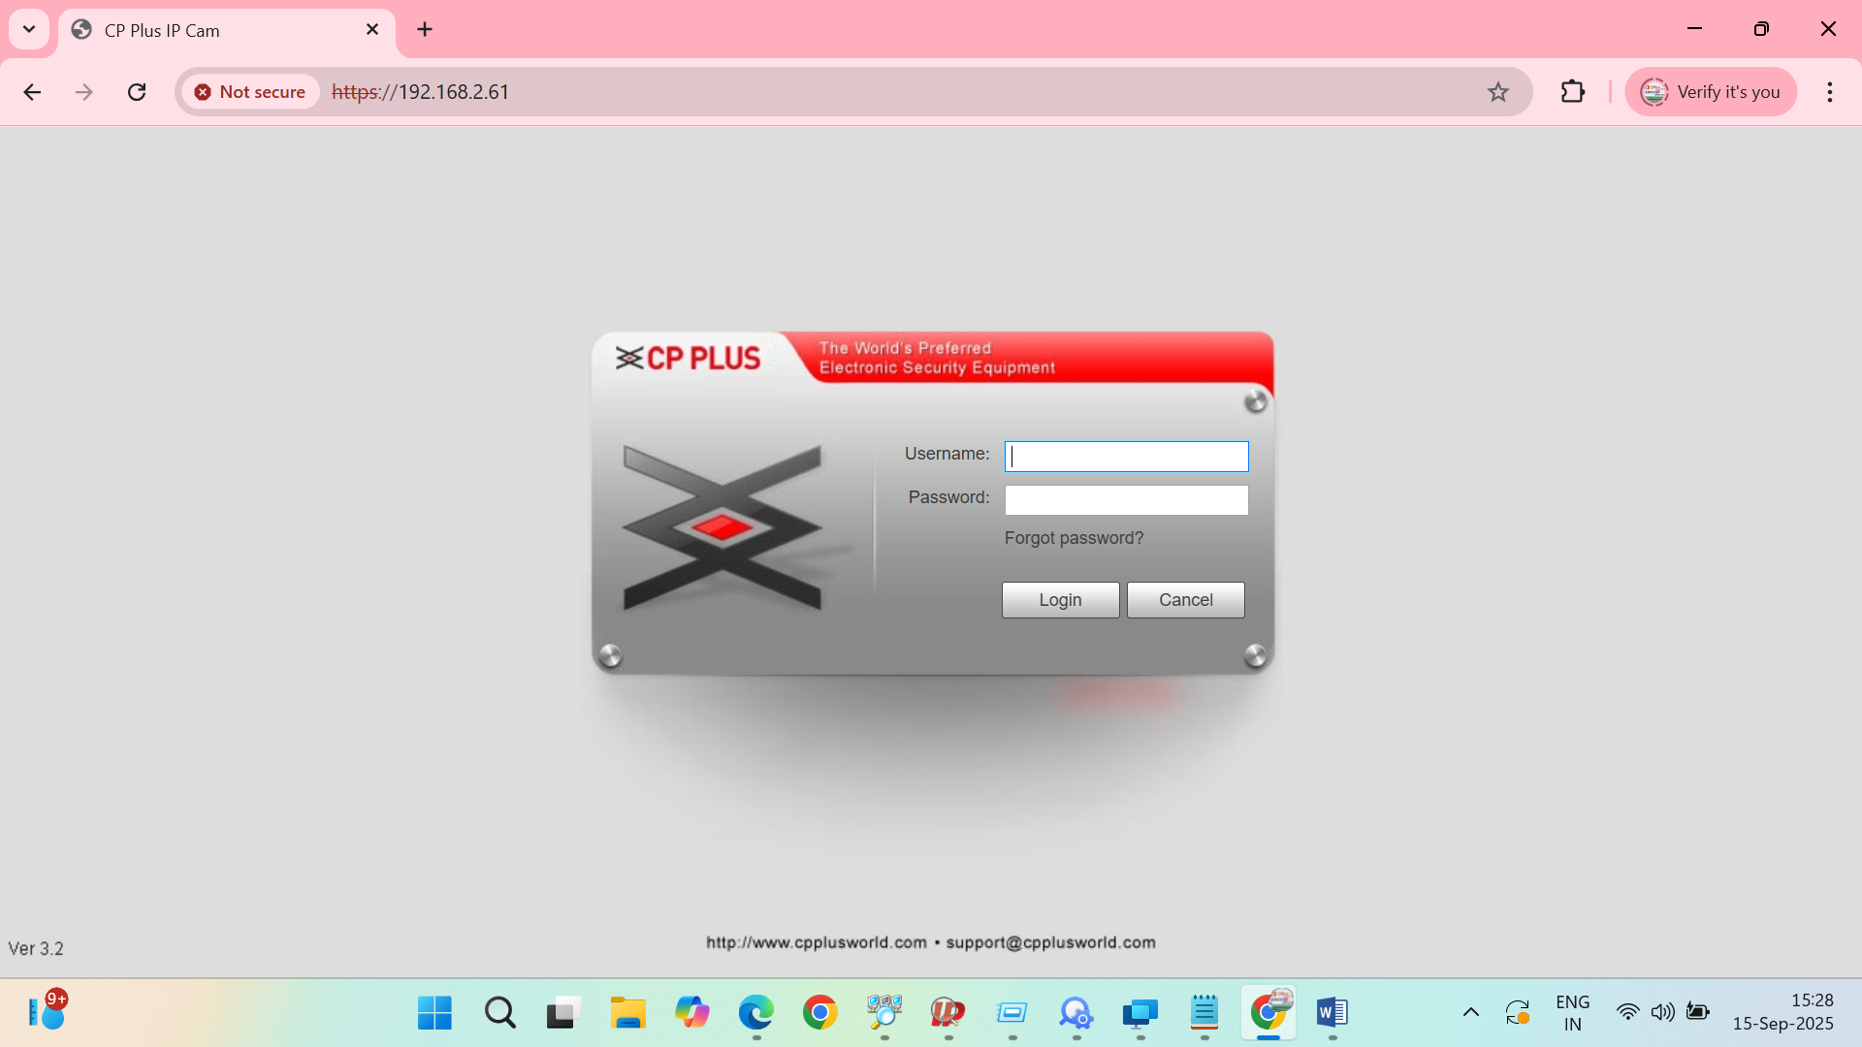

3 - Login to the camera and expand the system option then click on safety option, uncheck the option. As shown in the image below

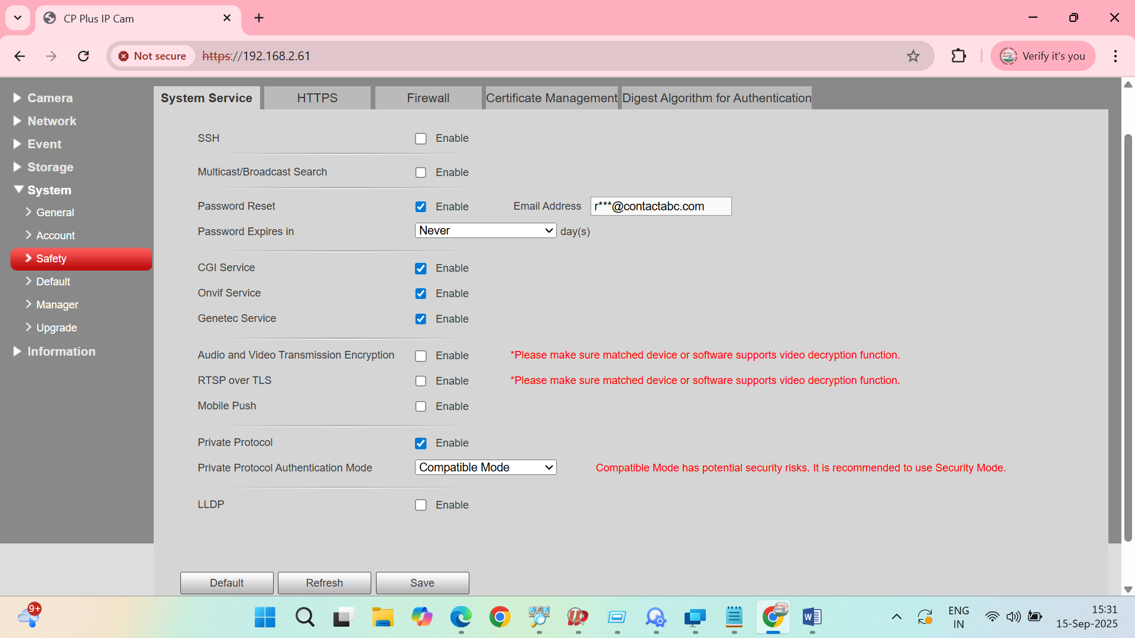

4 - expand the Network option then click on Access plateform option , and turn off ONVIF authentication

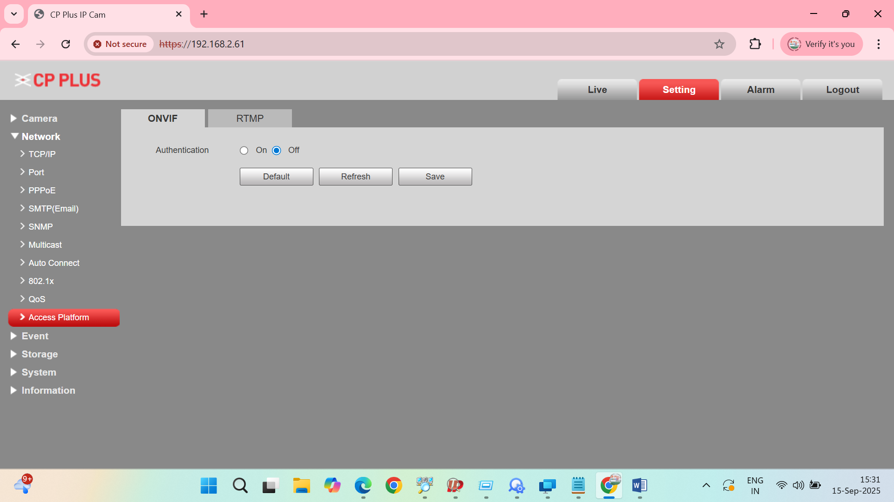

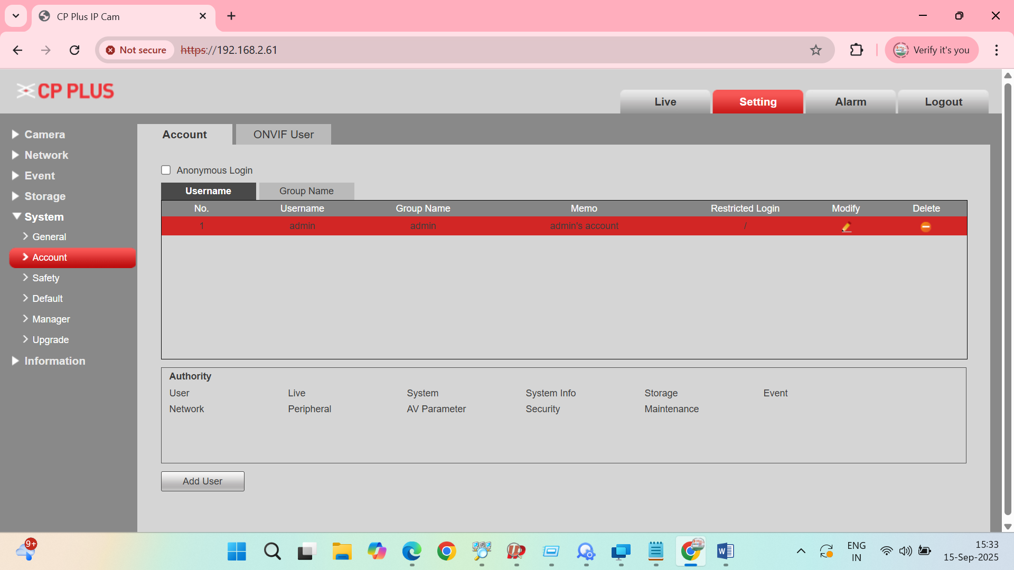

5 - Create an ONVIF user which is different from the login user password. And the user name should not be admin
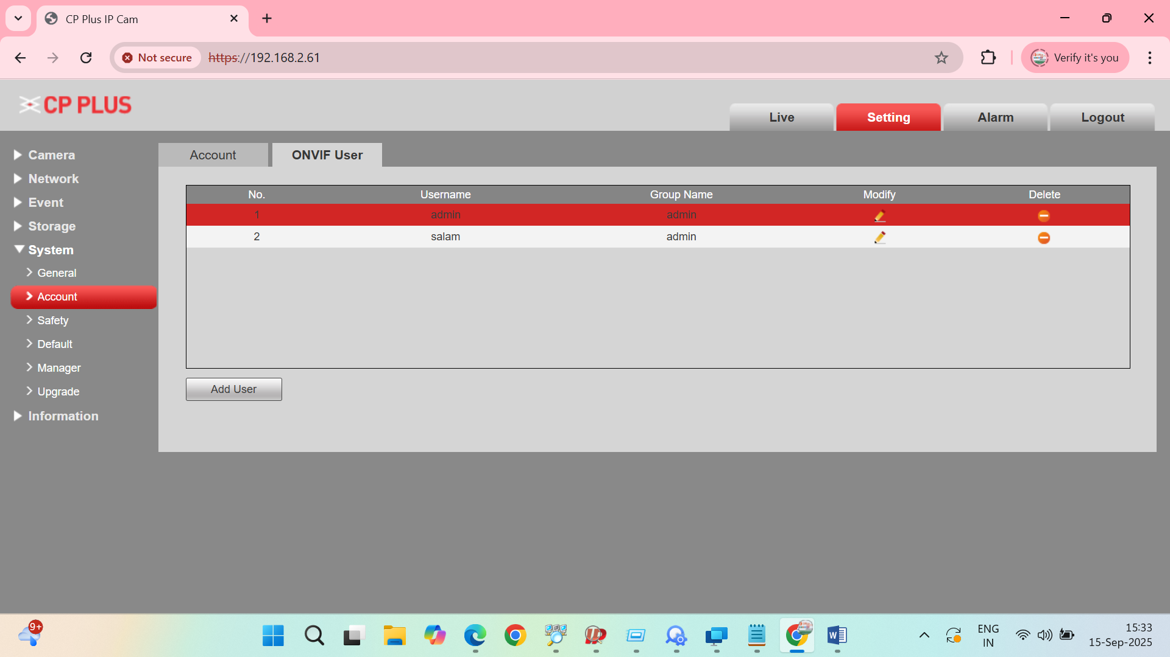

Add Menual Camera

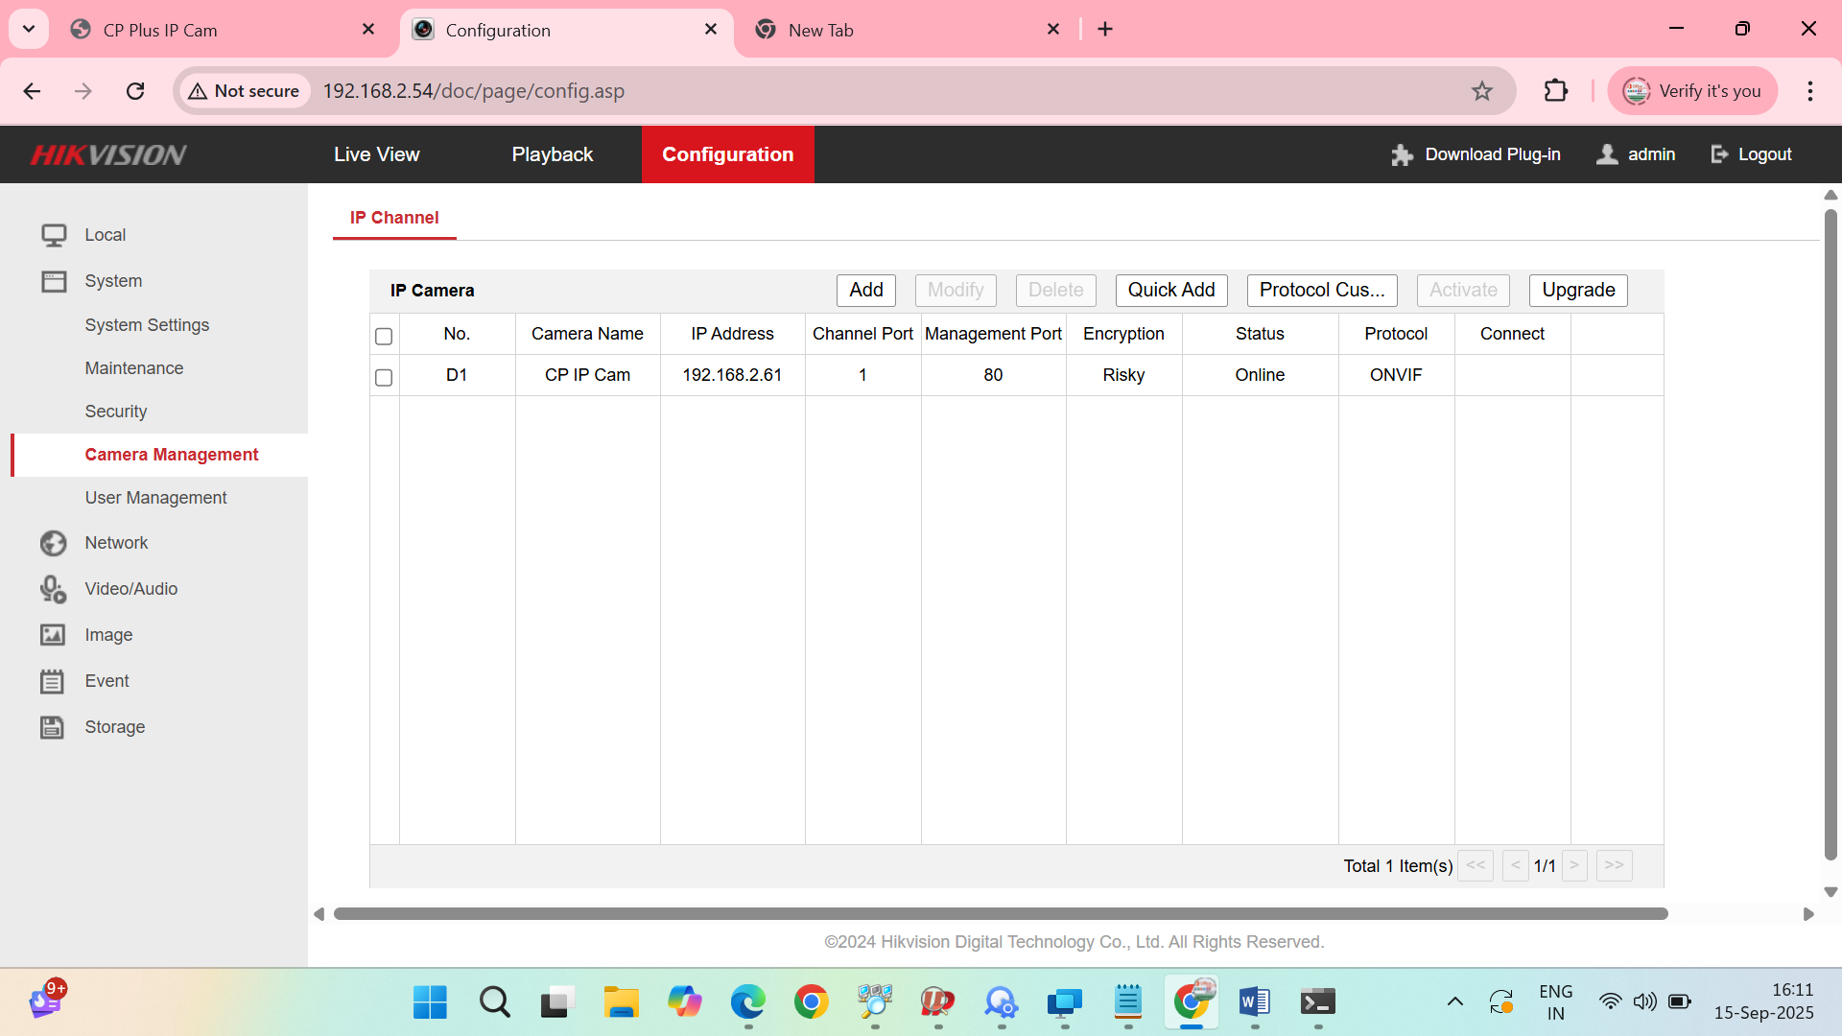

6 - Now enter ip, and in protocol select ONVIF, port 80, then enter ONVIF user password

